**1. Introduction to Voice Over IP (VoIP) or Telephony Service**

Voice over Internet Protocol (VoIP) is a type of technology that lets you to make free, or very low cost, calls over the internet. Mostly, we will be using Cisco devices such as routers, switches, IP phones, etc. to demonstrate the configuration. Therefore, we will be choosing these device types on the packet tracer for the demo;

1. **Cisco 2811 Router.**
2. **Cisco 2960 switch.**
3. **Cisco 7960 IP Phones.**
4. **Cisco PC-PT How to Configure Simple VoIP Service**

To understand how VoIP was implemented in the network topology above, kindly click on the link below to get every concept that is explained in a simpler language and terms.

1. **Draw Necessary Topology, Decorate and Comment.**

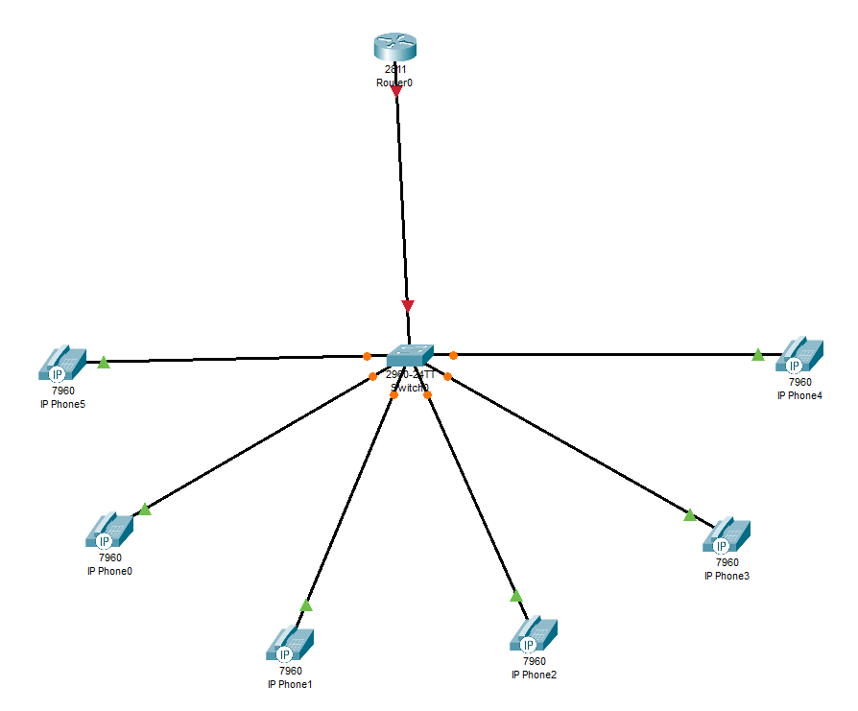

1. **Configure Switchports to Access Default Voice Vlan.**

|  |
| --- |
| Switch(config)#interface range fastEthernet 0/2-7  Switch(config-if-range)#switchport voice vlan 1  Switch(config-if-range)#exit  Switch(config)#interface fastEthernet 0/1  Switch(config-if)#switchport mode trunk  Switch(config-if)#exit  Switch(config)#do wr |

1. **Configure Trunk to the Interface Connecting to the Router & Configure IP on the Router Interface and Create a DHCP Pool for Voice.**

|  |
| --- |
| Router(config)#interface fastEthernet 0/0  Router(config-if)#no shutdown  Router(config-if)#ip address 10.10.10.1 255.255.255.0  Router(config-if)#exit  Router(config)#service dhcp  Router(config)#ip dhcp pool voice  Router(dhcp-config)#network 10.10.10.0 255.255.255.0  Router(dhcp-config)#default-router 10.10.10.1  Router(dhcp-config)#option 150 ip 10.10.10.1  Router(dhcp-config)#exit  Router(config)#do wr |

1. **Configure Telephony Service.**

|  |
| --- |
| Router(config)#telephony-service  Router(config-telephony)#max-ephones 6  Router(config-telephony)#max-dn 6  Router(config-telephony)#ip source-address 10.10.10.1 port 2000  Router(config-telephony)#auto assign 1 to 6  Router(config-telephony)#exit |

1. **Allocate Dial number / Extensions to the Phones.**

|  |
| --- |
| Router(config)#ephone-dn 1  Router(config-ephone-dn)#number 101  Router(config-ephone-dn)#exit  Router(config)#ephone-dn 2  Router(config-ephone-dn)#number 102  Router(config-ephone-dn)#exit  Router(config)#ephone-dn 3  Router(config-ephone-dn)#number 103  Router(config-ephone-dn)#exit  Router(config)#ephone-dn 4  Router(config-ephone-dn)#number 104  Router(config-ephone-dn)#exi  Router(config)#ephone-dn 5  Router(config-ephone-dn)#number 105  Router(config-ephone-dn)#exit    Router(config)#ephone-dn 6  Router(config-ephone-dn)#number 106  Router(config-ephone-dn)#exit  Router(config)#do wr |